AZURE TERRAFORM

**Aim**: - Create storage account blob container sas using the for_each meta-arguments and create Vnet using the module on azure portal by using the terraform.

# **Create storage account blob container sas using for_each meta-arguments and Create Vnet using the module on azure portal by using the terraform.**

Create storage account blob container sas using the for_each meta-arguments:

Configure the storage account blob container sas using for_each meta-arguments file by using the HCL.

provider.tf

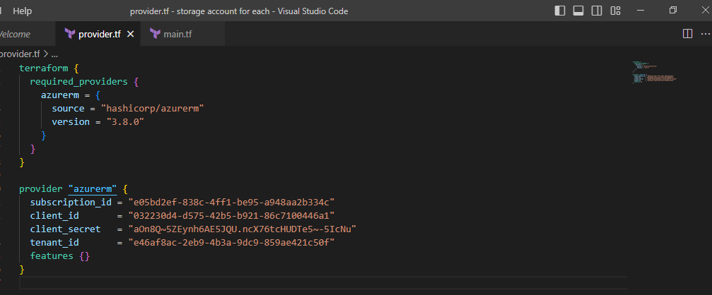

main.tf

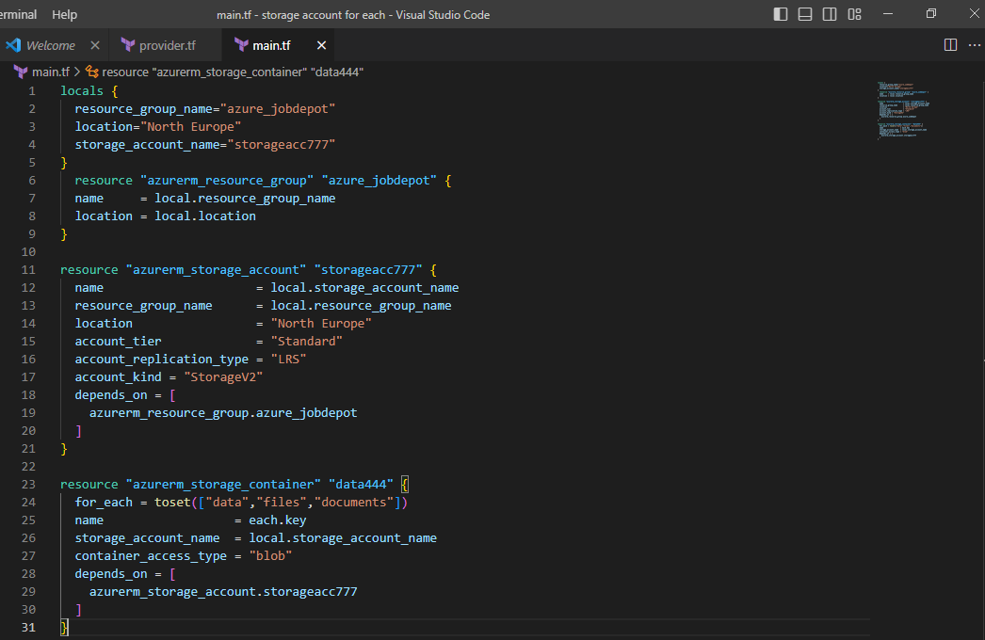

Initialize the terraform configuration file using the following command:

>terraform init

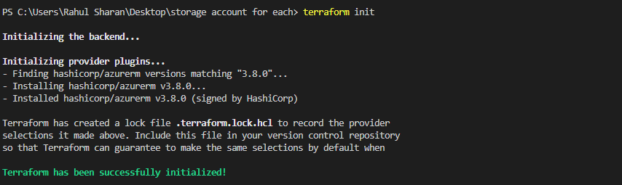

To create an execution plan for storage account blob container sas using for_each meta-arguments by using the following command:

>terraform plan –out main.tfplan

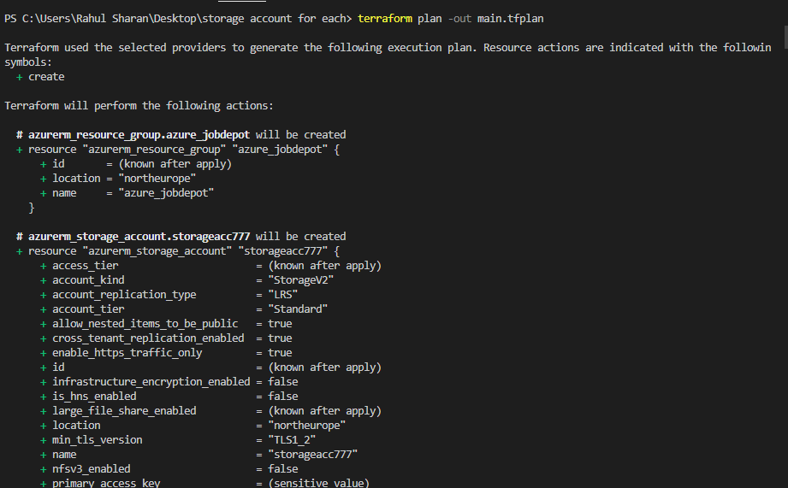

To execute the storage account blob container sas using for_each meta-arguments by using the following command:

>terraform apply

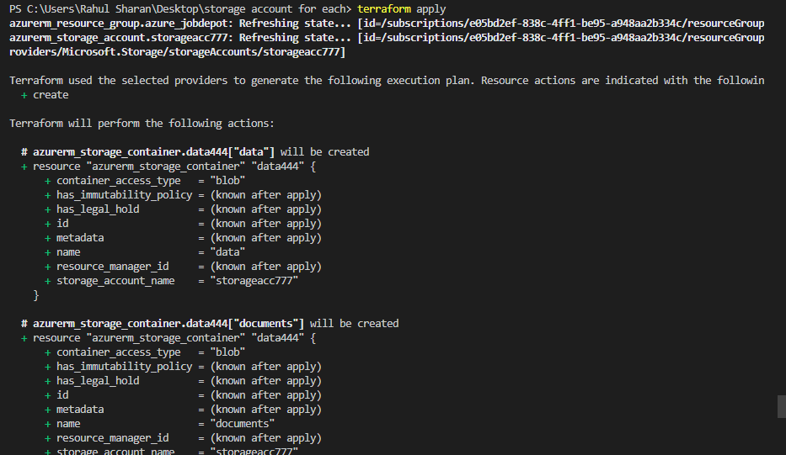

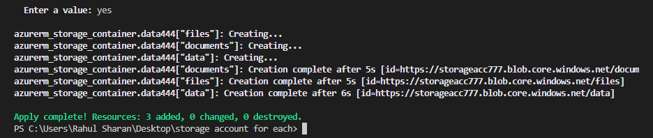

To verify the storage account blob container sas in azure portal:

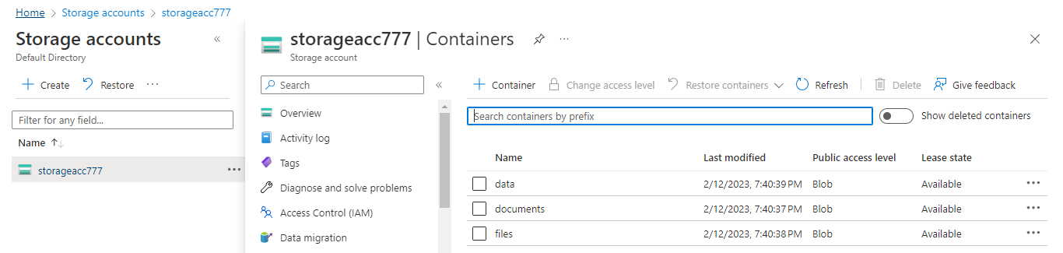

**To Build the networking using the module:**

Configure the Virtual network (Vnet) using module file by using the HCL.

main.tf

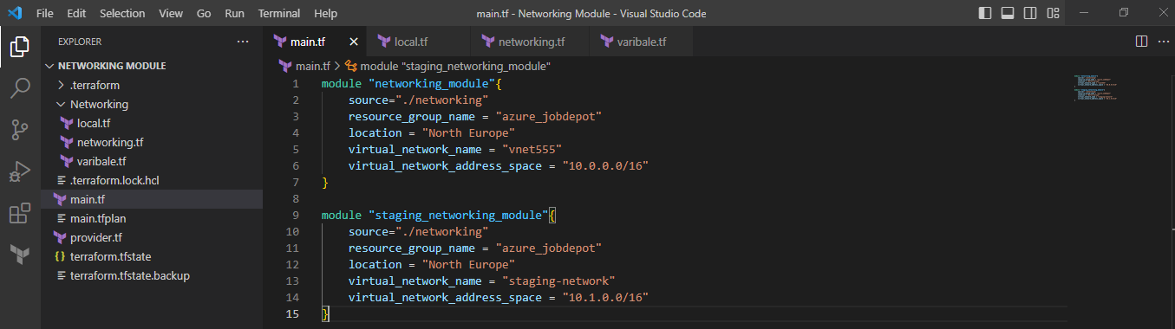

provider.tf

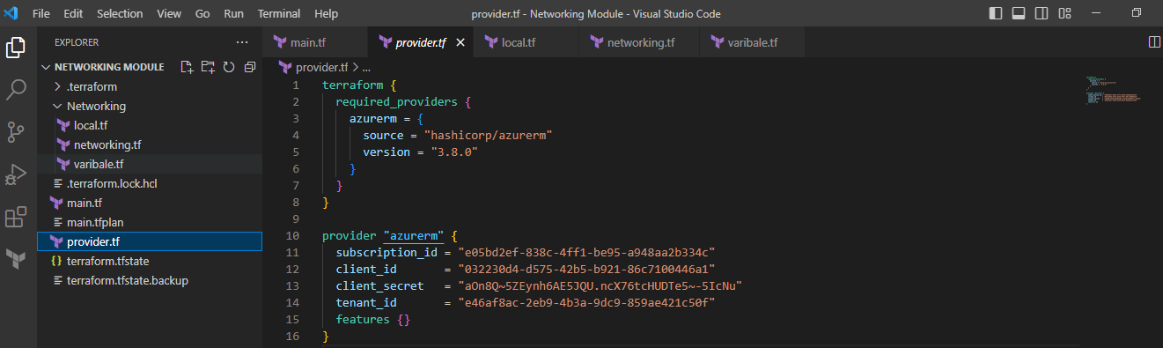

Networking:

local.tf

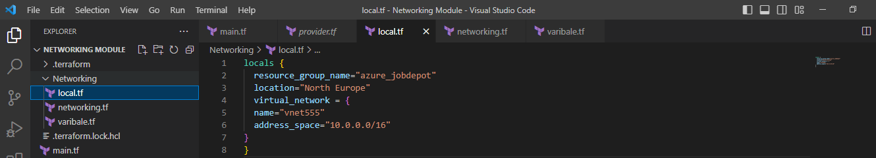

networking.tf

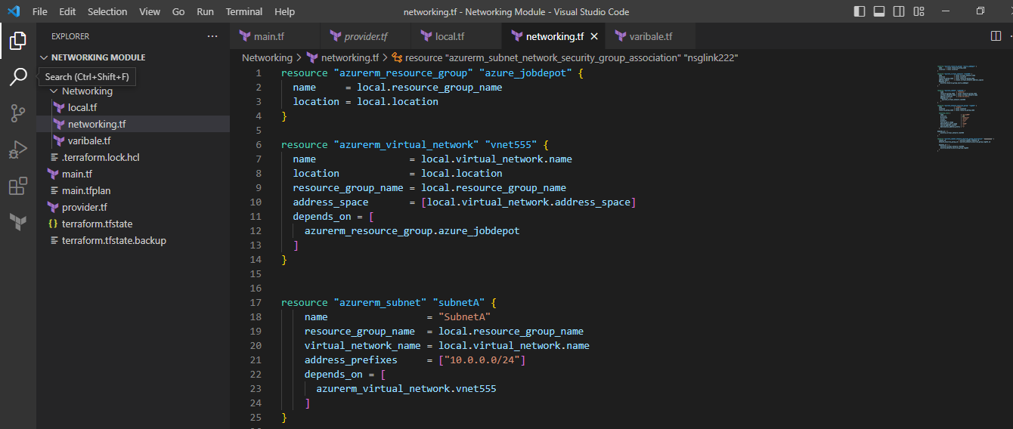

variable.tf

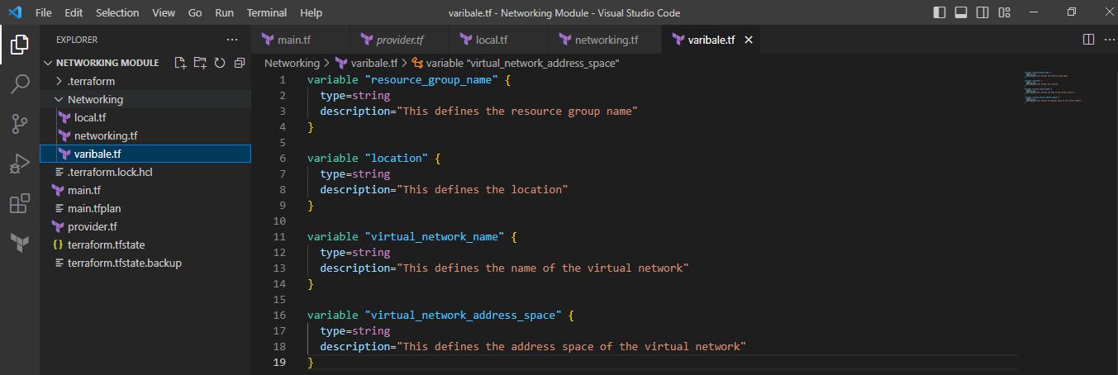

Initialize the terraform configuration file using the following command:

>terraform init

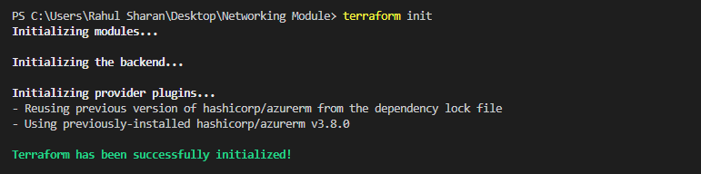

To create an execution plan for Virtual network (Vnet) using module by using the following command:

>terraform plan –out main.tfplan

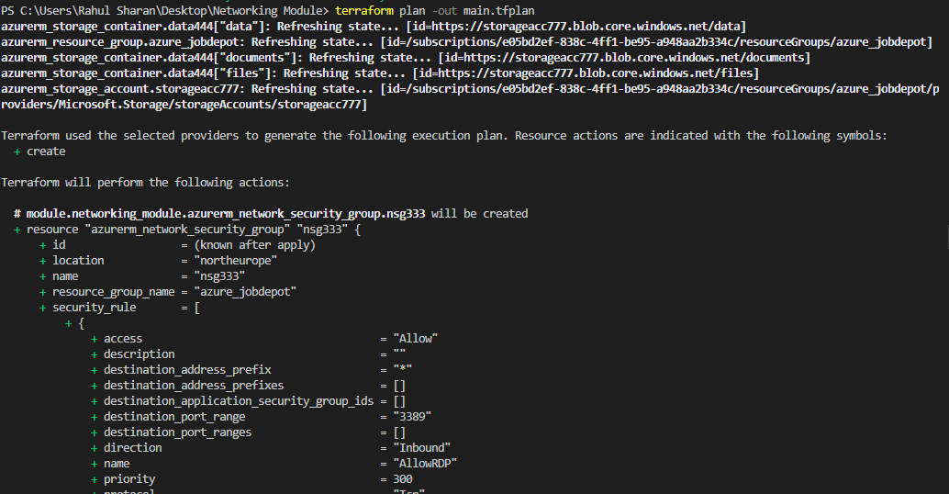

To execute the Virtual network (Vnet) using module by using the following command:

>terraform apply

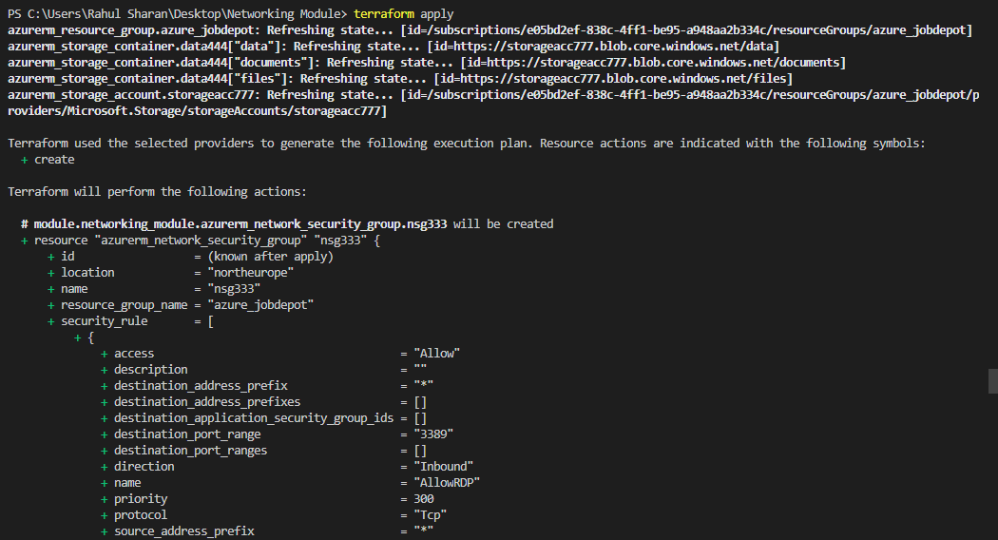

To verify the Virtual network (Vnet) using module in azure portal:

